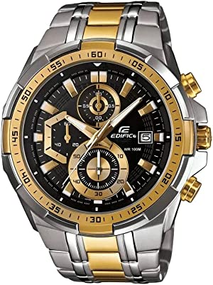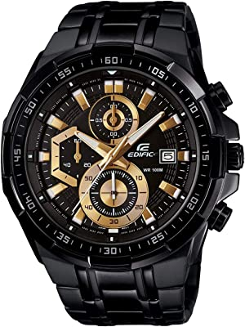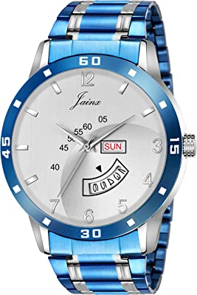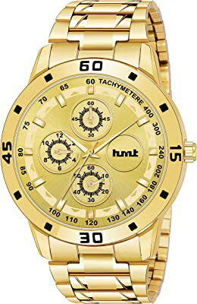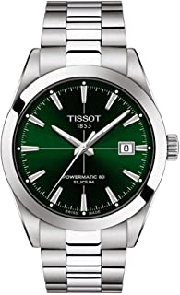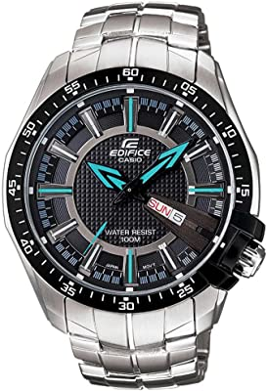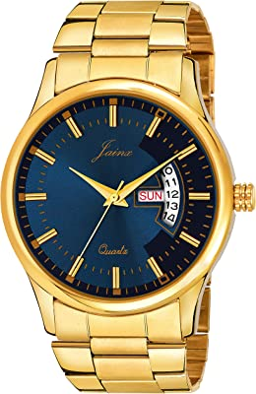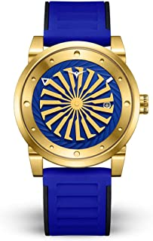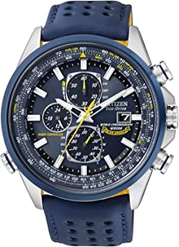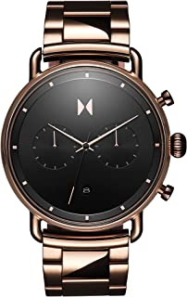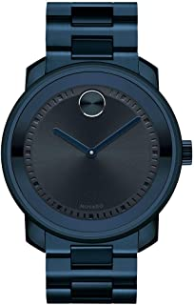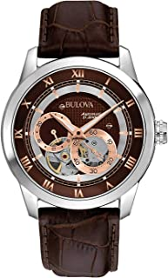
PREMIUM WATCHES

SVESTON U084

PRICE: 92,000 PKR

CLASICO X40

PRICE: 91,000 PKR

LORUS

P
4
2

PRICE: 93,000 PKR

CITIZEN

E54

PRICE: 29,000 PKR

LORUS

E98

PRICE: 83,00
0
PKR

G
-
SHOCK Y
0
2

PRICE: 93,000 PKR

OMEGA SM05

PRICE: 85,000 PKR

SHOCK H53

PRICE: 67,000 PKR

TAG HEUER Z52

PRICE: 50,000 PKR

SEIKO L8
38

PRICE:98,000 PKR

CASIO M07

PRICE: 83,000 PKR

CASIO

J97

PRICE:49,000 PKR

